|  |  |
| --- | --- |
| **PLC Splitter** | **Tray Type PLC Splitter** |
|  |  |

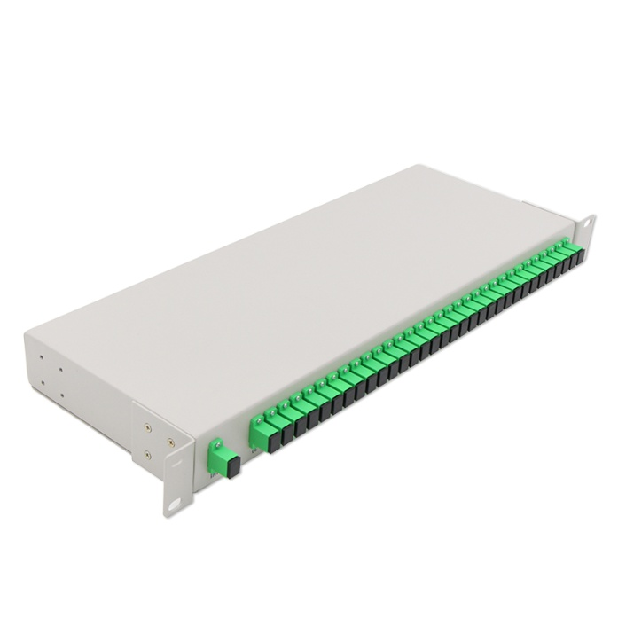 **FEA**

**TU**

**DESCRIPTION**

Welltech Enterprises PLC splitter is based on silicon dioxide waveguides, which is used to connect main equipment and terminal equipment in EPON, BPON and GPON network.

**FEATURES**

* Qualified with CE certificate and ROHS certificate.
* Comply with GR-1209-CORE, GR-1221-CORE, YD/T 2000.1-2014 and IEC criterion.

**HOUSING SIZE AND RIBBION:**

|  |  |  |  |  |
| --- | --- | --- | --- | --- |
|  |  |  | |  |
|  | **T3.1** | **Tray type PLC Splitter dimension** | |  |
| Dimension | nx2, nx4, nx8, nX16 |  | 1X32, 2X32 | 1X64, 2X64 |
|  |  |  |  |  |
| L x W x H (mm) | 288×180×25 |  | 288×180×50 | 288×180×100 |
|  |  |  |  |  |

**OPTICAL PARAMETER:**

**T4.1 1×N (N≥2)PLC splitter optical parameter**

|  |  |  |  |  |  |  |  |  |  |  |  |  |
| --- | --- | --- | --- | --- | --- | --- | --- | --- | --- | --- | --- | --- |
|  |  |  | Parameter | 1X2 | 1x4 |  | 1x8 |  | 1x16 |  | 1x32 | 1x64 |
|  |  | |  |  |  |  |  | |  |  |  |  |
|  | Wavelength (nm) | | |  |  |  | 1260 ～ 1650 | | | |  |  |
|  |  |  |  |  |  |  |  |  |  |  |  |  |
|  |  |  | IL (dB) | ≤4.1 | ≤7.4 |  | ≤10.5 |  | ≤13.8 |  | ≤17.1 | ≤20.4 |
|  |  | |  |  |  |  |  |  |  |  |  |  |
|  | Uniformity (dB) | | | ≤0.6 | ≤0.7 |  | ≤0.8 |  | ≤1.0 |  | ≤1.5 | ≤2.0 |
|  |  |  |  |  |  |  |  | |  |  |  |  |
|  |  |  | RL (dB) |  |  |  | ≥50(PC); ≥55(APC) | | | |  |  |
|  |  |  |  |  |  |  |  |  |  |  |  |  |
|  |  |  | PDL (dB) | ≤0.15 | ≤0.2 |  | ≤0.2 |  | ≤0.3 |  | ≤0.3 | ≤0.3 |
|  |  |  |  |  |  |  |  |  |  |  |  |  |
|  |  | Directivity (dB) | | ≥55 | ≥55 |  | ≥55 |  | ≥55 |  | ≥55 | ≥55 |
|  |  |  |  |  |  |  |  |  |  |  |  |  |
|  |  |  | Operating temp(℃) |  |  |  |  | -40~85℃ | | |  |  |
|  |  |  |  |  |  |  |  |  |  |  |  |  |
| Environ | |  | Storage temp(℃) |  |  |  |  | -40~85℃ | | |  |  |
|  |  |  |  |  |  |  |  |  |  |  |
|  | Humidity |  |  |  | ≤95%（+40℃） | | | |  |  |
| ment |  |  |  |  |  |  |  |
|  |  |  |  |  |  |  |  |  |  |  |  |
|  |  | Atmospheric |  |  |  |  | 62~106kPa | | |  |  |
|  |  |  |  |  |  |  |  |  |
|  |  |  | pressure |  |  |  |  |  |  |
|  |  |  |  |  |  |  |  |  |  |  |  |
|  |  |  |  |  |  |  |  | |  |  |  |  |
|  |  |  | Fiber |  |  |  | SM G657A or customized | | | |  |  |
|  |  |  |  |  |  |  |  |  |  |  |  |  |
|  |  |  | Connector |  |  |  |  | SC, FC, LC | | |  |  |
|  |  |  |  |  |  |  |  | |  |  | |  |
|  |  | Pigtail (mm) | |  |  | 1000, 1500, 2000 or customized | | | | | |  |
|  |  |  |  |  |  |  |  |  |  |  |  |  |

**T4.2 2×N (N≥2) PLC splitter optical parameter**

|  |  |  |  |  |  |  |  |  |  |  |  |  |  |  |  |  |  |  |
| --- | --- | --- | --- | --- | --- | --- | --- | --- | --- | --- | --- | --- | --- | --- | --- | --- | --- | --- |
|  |  |  | Parameter | 2X2 | 2x4 |  | | 2x8 | |  | 2x16 | | |  | | 2x32 | 2x64 | |
|  |  | |  |  |  |  | |  | | |  | | |  | |  |  | |
|  | Wavelength (nm) | | |  |  |  | | 1260 ～ 1650 | | | | | | | |  |  | |
|  |  |  |  |  |  |  | |  | |  |  | | |  | |  |  | |
|  |  |  | IL (dB) | ≤4.4 | ≤7.7 |  | | ≤10.8 | |  | ≤14.1 | | |  | | ≤17.4 | ≤20.7 | |
|  |  | |  |  |  |  | |  | |  |  | | |  | |  |  | |
|  | Uniformity (dB) | | | ≤0.8 | ≤1.0 |  | | ≤1.0 | |  | ≤1.5 | | |  | | ≤1.8 | ≤2.0 | |
|  |  |  |  |  |  |  | |  | | |  | | |  | |  |  | |
|  |  |  | RL (dB) |  |  |  | | ≥50(PC); ≥55(APC) | | | | | | | |  |  | |
|  |  |  |  |  |  |  | |  | |  |  | | |  | |  |  | |
|  |  |  | PDL (dB) | ≤0.2 | ≤0.2 |  | | ≤0.3 | |  | ≤0.3 | | |  | | ≤0.3 | ≤0.4 | |
|  |  |  |  |  |  |  | |  | |  |  | | |  | |  |  | |
|  |  | Directivity (dB) | | ≥55 | ≥55 |  | | ≥55 | |  | ≥55 | | |  | | ≥55 | ≥55 | |
|  |  |  |  |  |  |  | |  | |  |  | | |  | |  |  | |
|  |  |  | Operating temp(℃) |  |  |  | |  | | -40~85℃ | | | | | |  |  | |
|  |  |  |  |  |  |  | |  | |  |  | | |  | |  |  | |
| Environ | |  | Storage temp(℃) |  |  |  | |  | | -40~85℃ | | | | | |  |  | |
|  |  |  |  |  | |  | |  |  | | |  | |  |  | |
|  | Humidity |  |  |  | | ≤95% (+40℃) | | | | | | | |  |  | |
| ment |  |  |  |  |  | |  |  | |
|  |  |  |  |  |  | |  | |  |  | | |  | |  |  | |
|  |  | Atmospheric |  |  |  | |  | | 62~106kPa | | | | | |  |  | |
|  |  |  |  |  |  | |  | |  |  | |
|  |  |  | pressure |  |  |  | |  | |  |  | |
|  |  |  |  |  |  | |  | |  |  | | |  | |  |  | |
|  |  |  | Fiber |  |  |  | | SM G657A or customized | | | | | | | |  |  | |
|  |  |  |  |  |  |  | |  | |  |  | | |  | |  |  | |
|  |  |  | Connector |  |  |  | |  | | SC, FC, LC | | | | | |  |  | |
|  |  |  |  |  |  |  | |  | | |  | | |  | | |  | |
|  |  | Pigtail (mm) | |  |  | 1000, 1500, 2000 or customized | | | | | | | | | | |  | |
|  |  |  |  |  |  |  |  | | |  |  | | |  | |  |  | |
|  |  |  |  |  |  |  | | |  | | |  |  | |  | | |